HW 5: due 2/19;

Complete the C++ Books Collection demo package example discussed in class. Specifically, you need to provide the implementation for the following methods in books.cpp

Book BookCollection::FindBook(int id)

bool BookCollection::DeleteBook(int id)

You can find the code for this package in lecture9_examples.tar.gz tarball which is available on lecture course page here: <https://mwcorley79.github.io/MikeCorley/lecture9/lecture9_examples.tar.gz>.

Note: If you open Firefox from within the Linux Mint VM you can download the tarball directly into the VM. Otherwise you can download the code from your host machine and drag it into a folder in the VM.

Once the lecture9_examples.tar.gz is downloaded to a folder in your VM you can extract the code with the following command: tar xvfz lecture9_examples.tar.gz. See screen shot below:

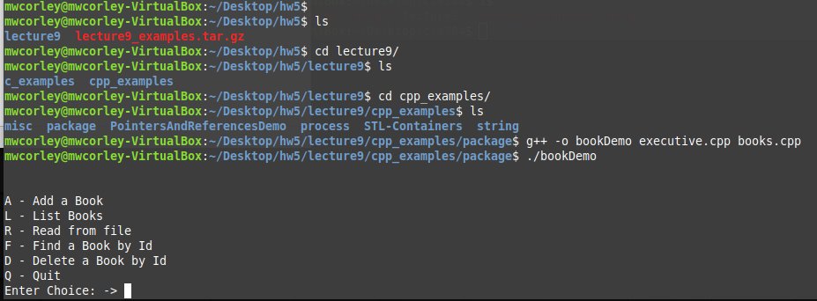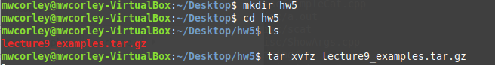

Use nano or vi to open books.cpp and supply the code for the methods shown

Note: you can install a g++ compiler with the following command: *sudo apt-get install g++*

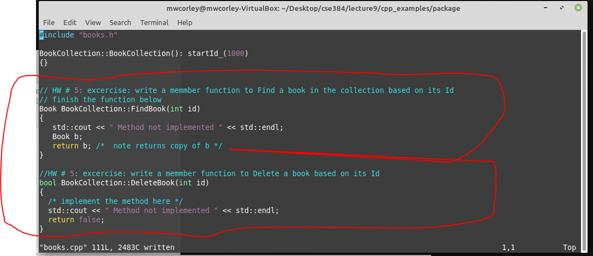

Once complete, please submit your code and output screen shots to Blackboard.

If you feel ambitious, I recommend you complete the same exercise for the C package examples located in “lecture9/c_examples/package”, but this not a requirement for HW5

TAs will be available in class next week to help and to answer general C/C++ questions. Take the time next week to experiment and study the code examples.

Example run

